**Practical No. 01**

**AIM:** Exploratory Data Analysis(EDA) and Data Visualization

1. eda_data<-read.csv(file.choose(),header=TRUE,sep=",") eda_data

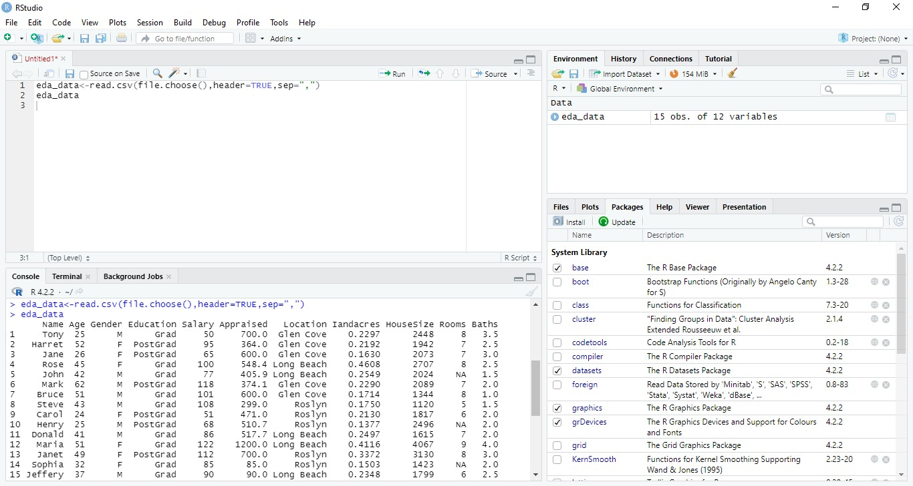

1. head(eda_data)

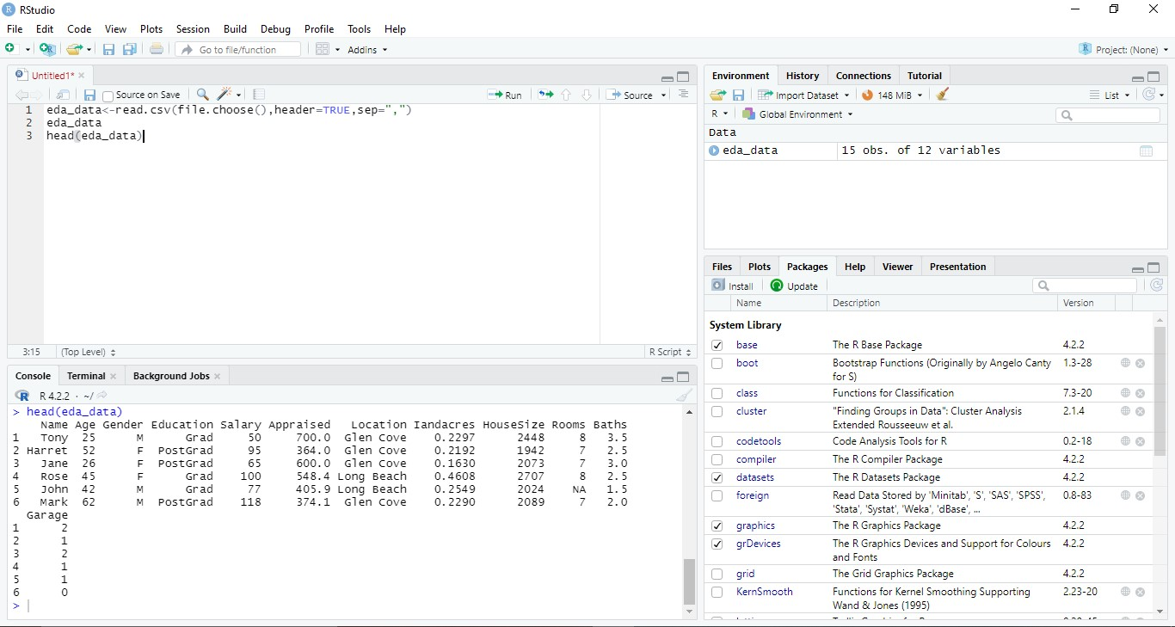

3)summary(eda_data)

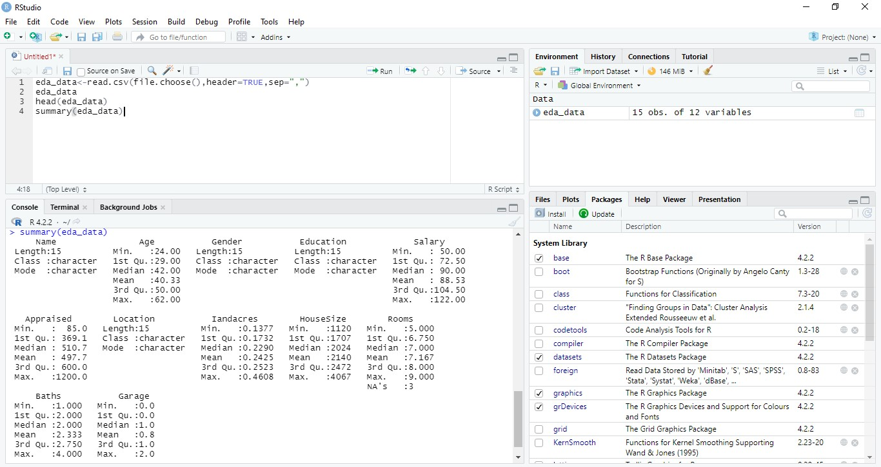

1. str(eda_data)

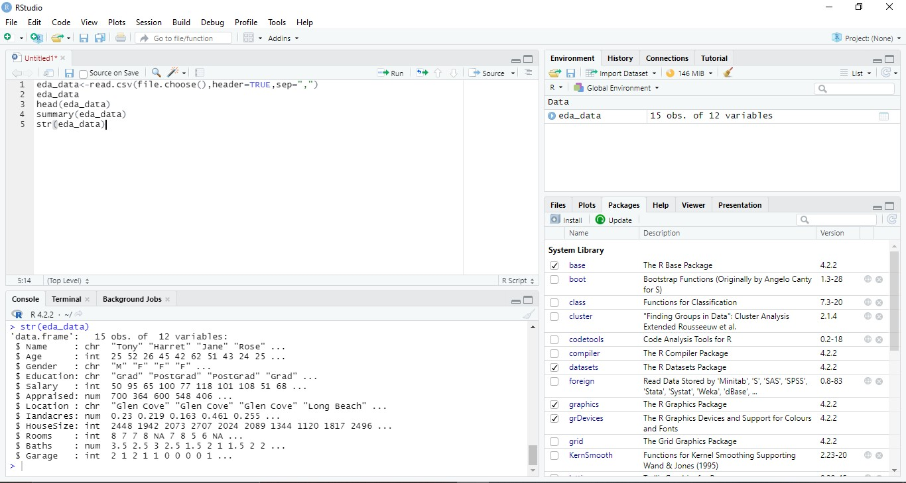

1. eda_data[1:8]

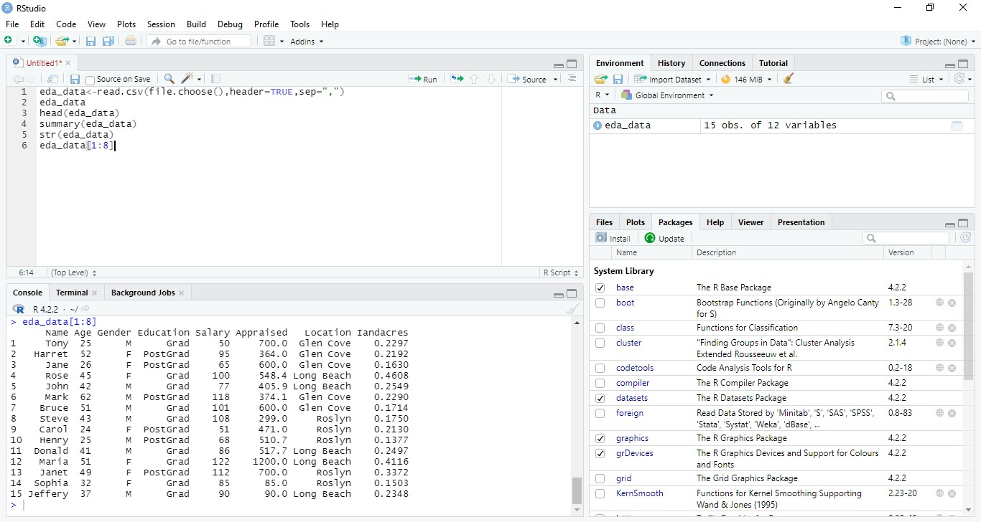

1. head(eda_data,3)

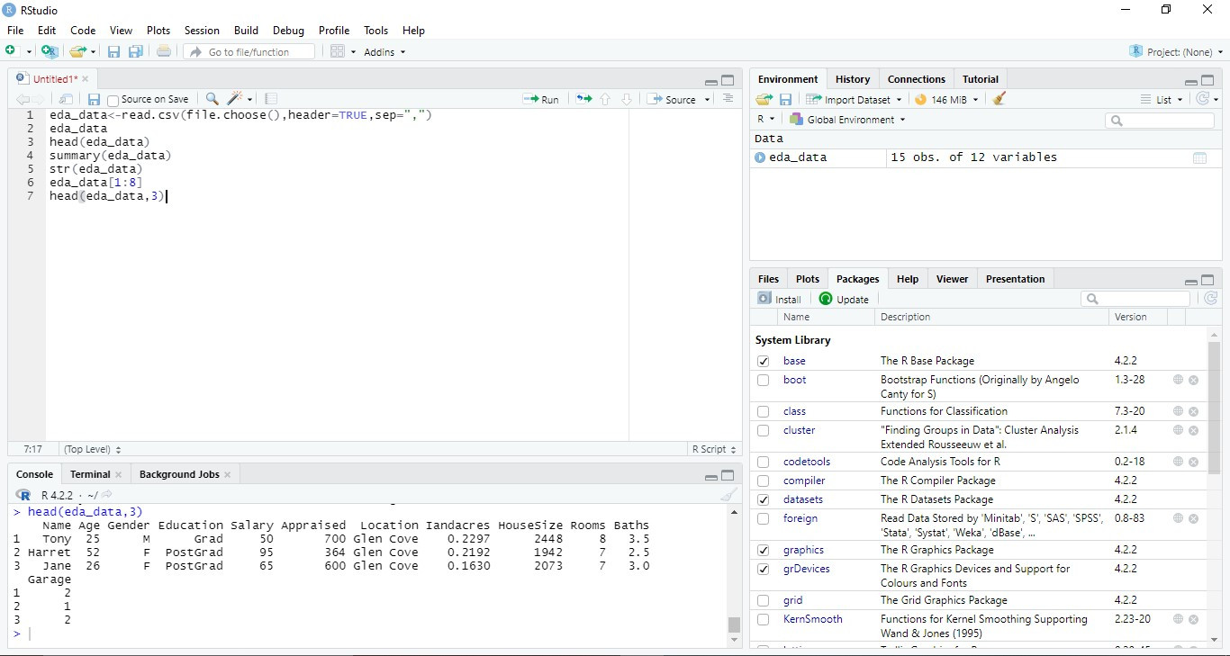

1. head(eda_data,8)

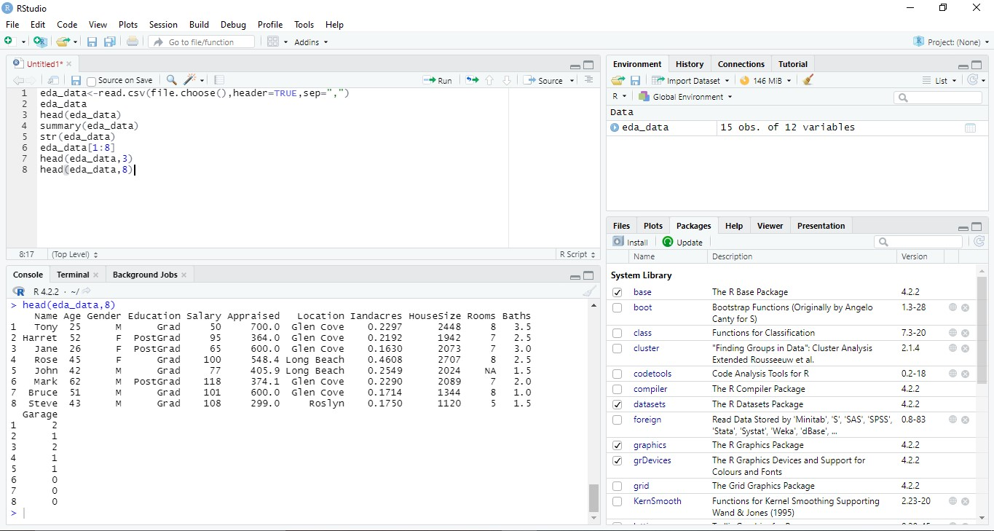

1. tail(eda_data,8)

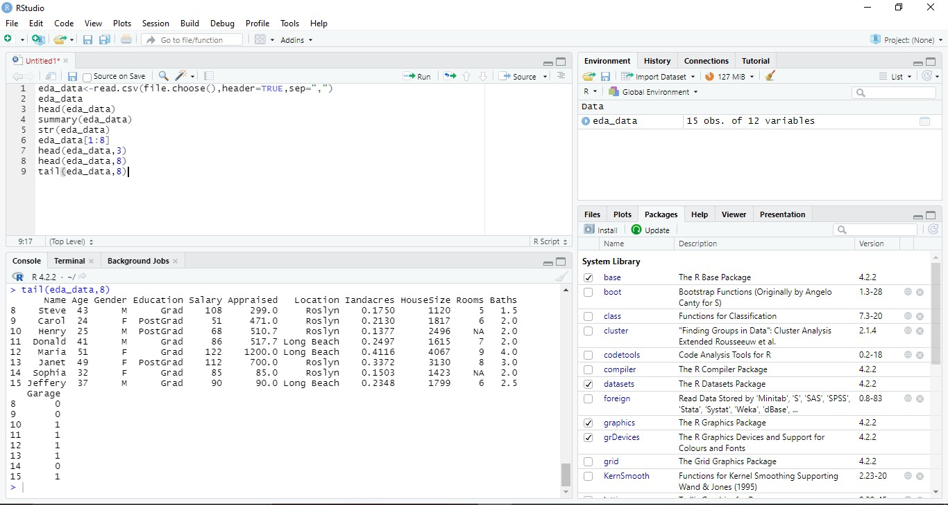

1. eda_data[,1:5]

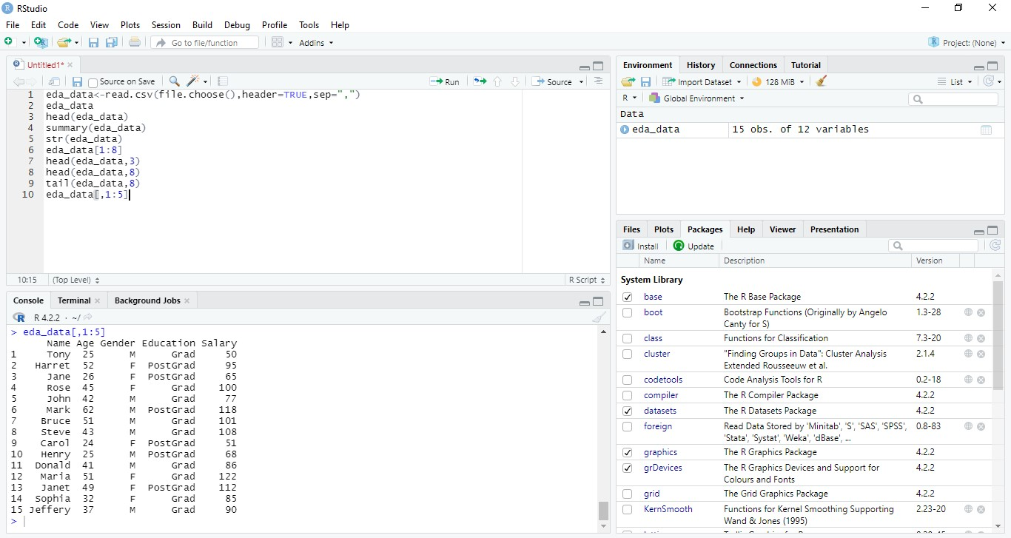

1. newdata1<-subset(eda_data,eda_data$Education == "Grad")

newdata1

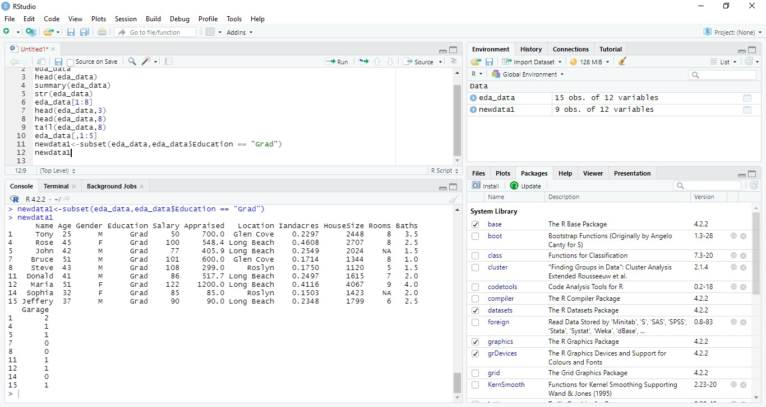

1. newdata2<-subset(eda_data,eda_data$Age=="51" & eda_data$Gender== "M")

newdata2

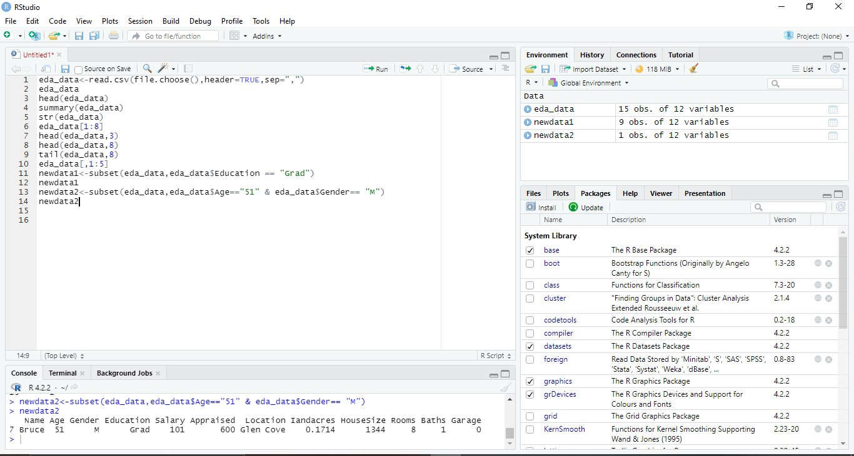

1. a<-eda_data[order(eda_data$Education),]

a

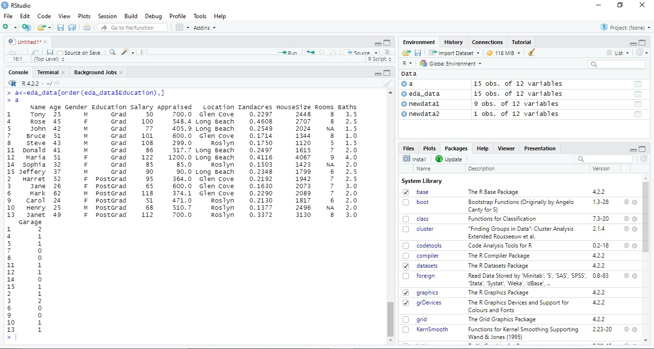

1. a<-eda_data[order(eda_data$Education,decreasing = TRUE),]

a

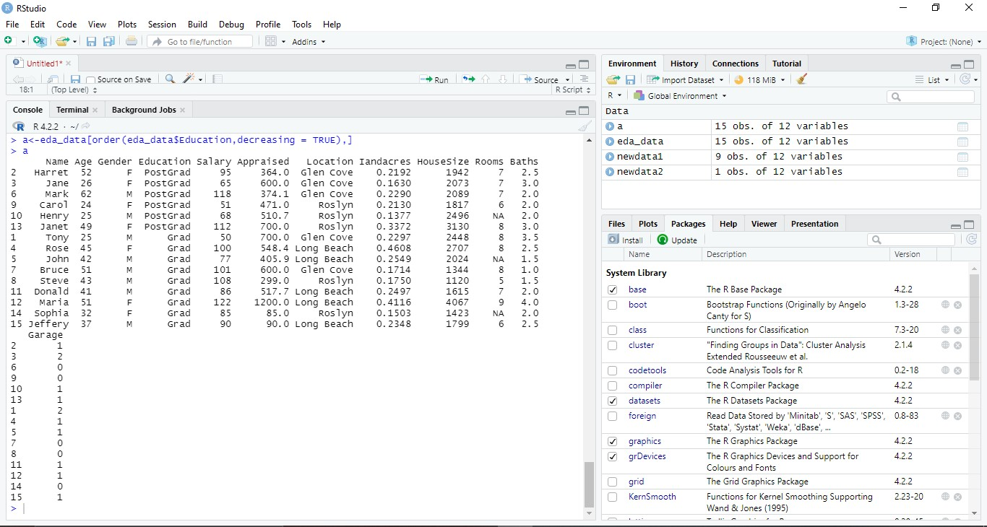

1. a<-colSums(is.na(eda_data))

a

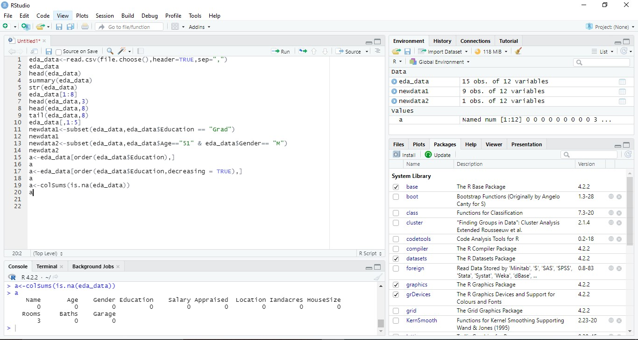

1. histogram

hist(eda_data$Age)

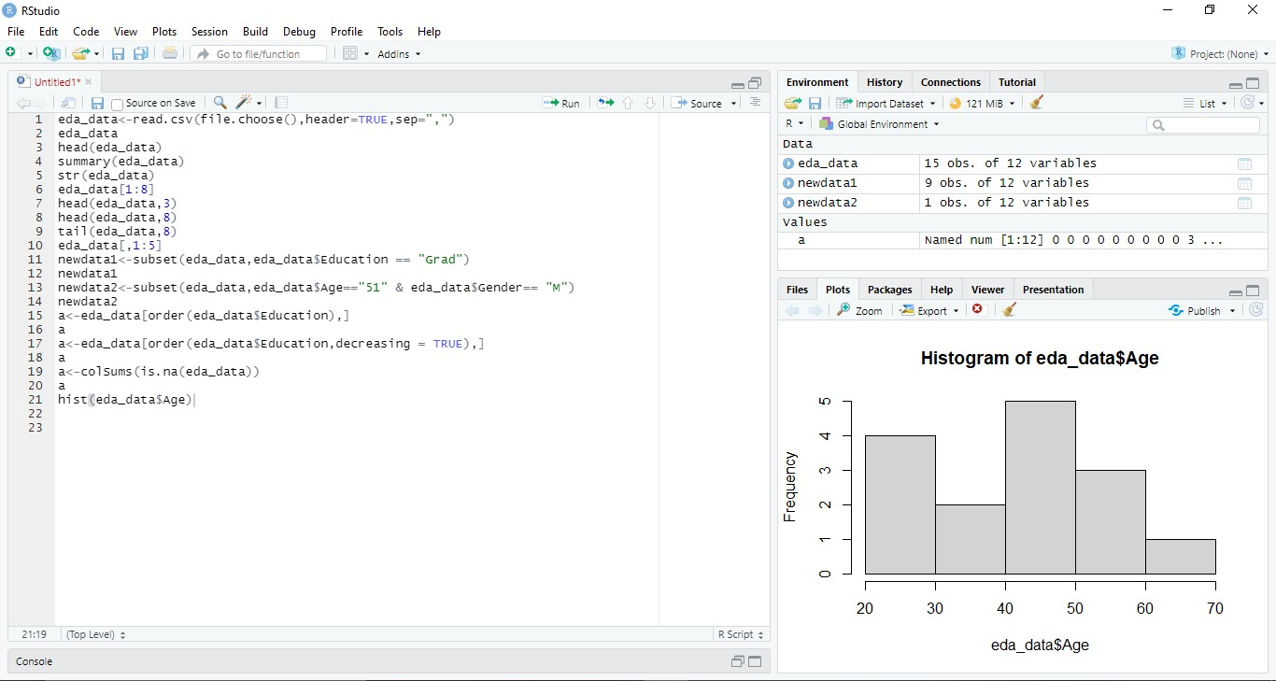

1. boxplot(eda_data$Age)

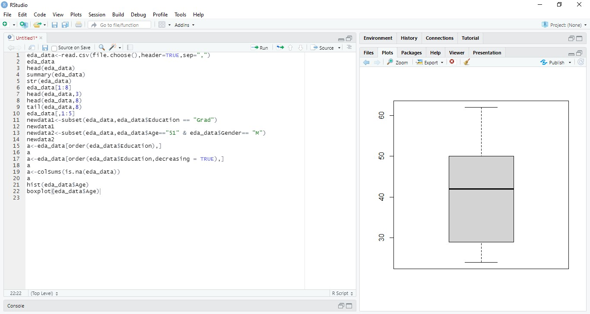

1. mean(eda_data$Age)

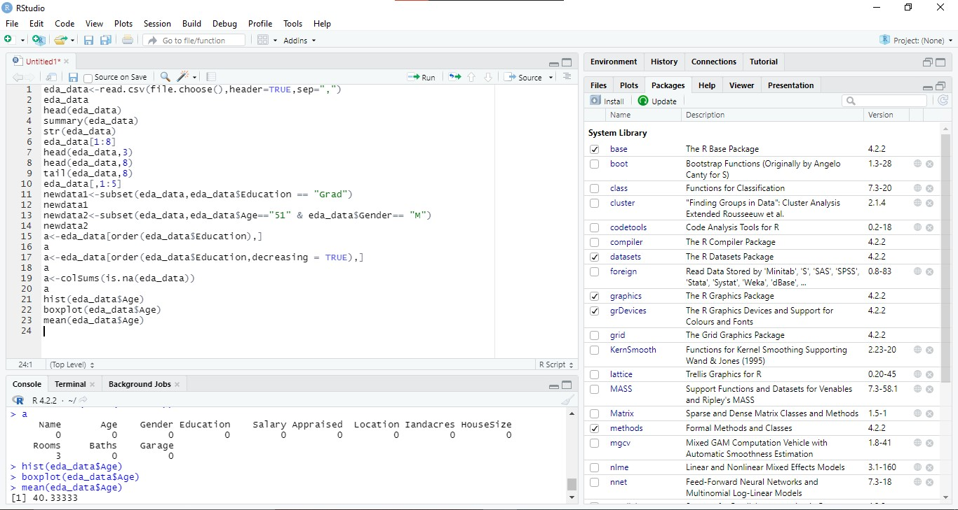

18)min(eda_data$Age)



1. max(eda_data$Age)

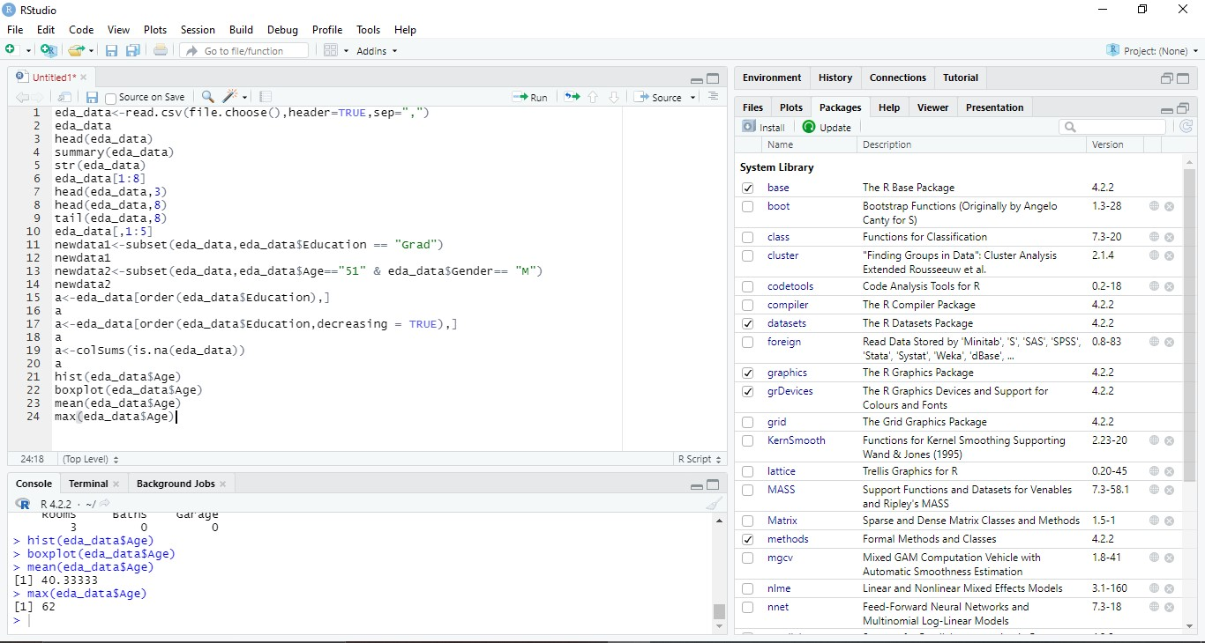

1. median(eda_data$Age)



1. barplot counts= table(eda_data$Education,eda_data$Gender) counts



1. help("pie")#to know more about pie use this help

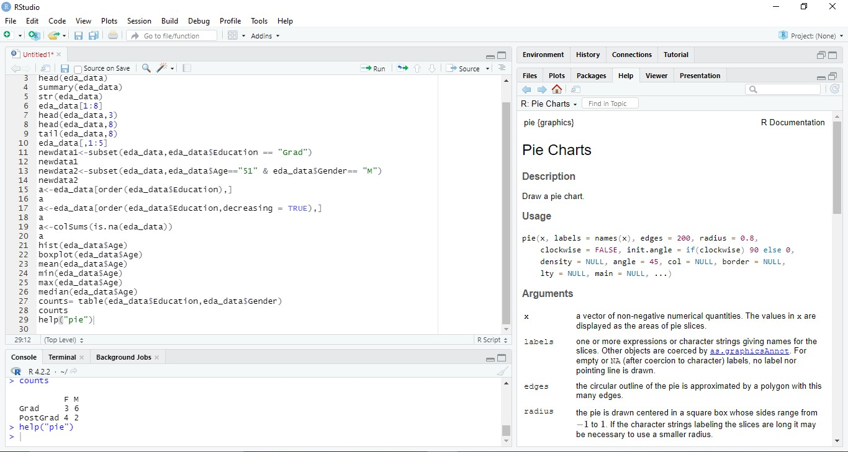

1. scatterplot

plot(eda_data$Age,eda_data$Salary)

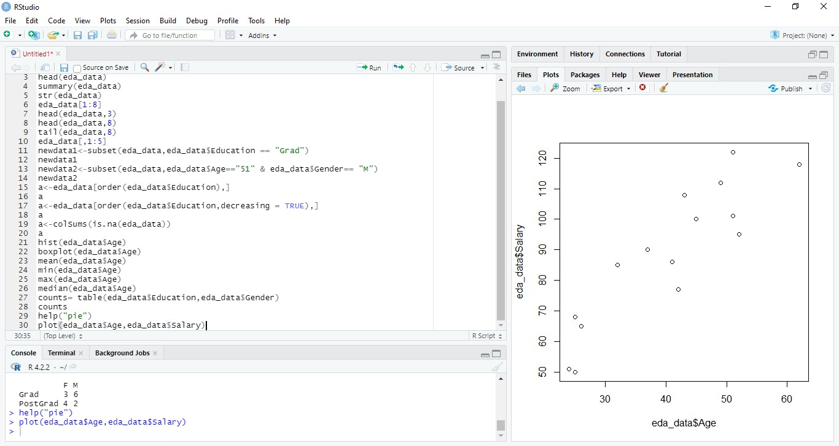

1. line-plot

plot(eda_data$Salary,type = "p" , col = "red" , main = "Salary" , xlim= c(0,10), ylim = c(0,10))

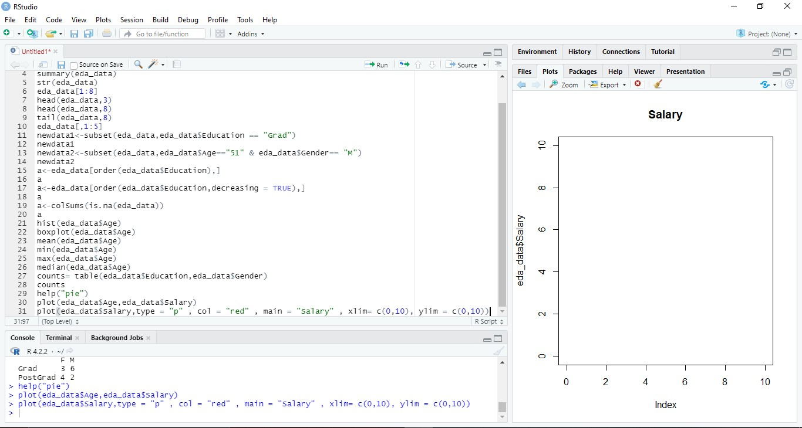

25)hist(eda_data$Age,col = "green", border ="red", xlim = c(20,70),ylim = c(0,70))

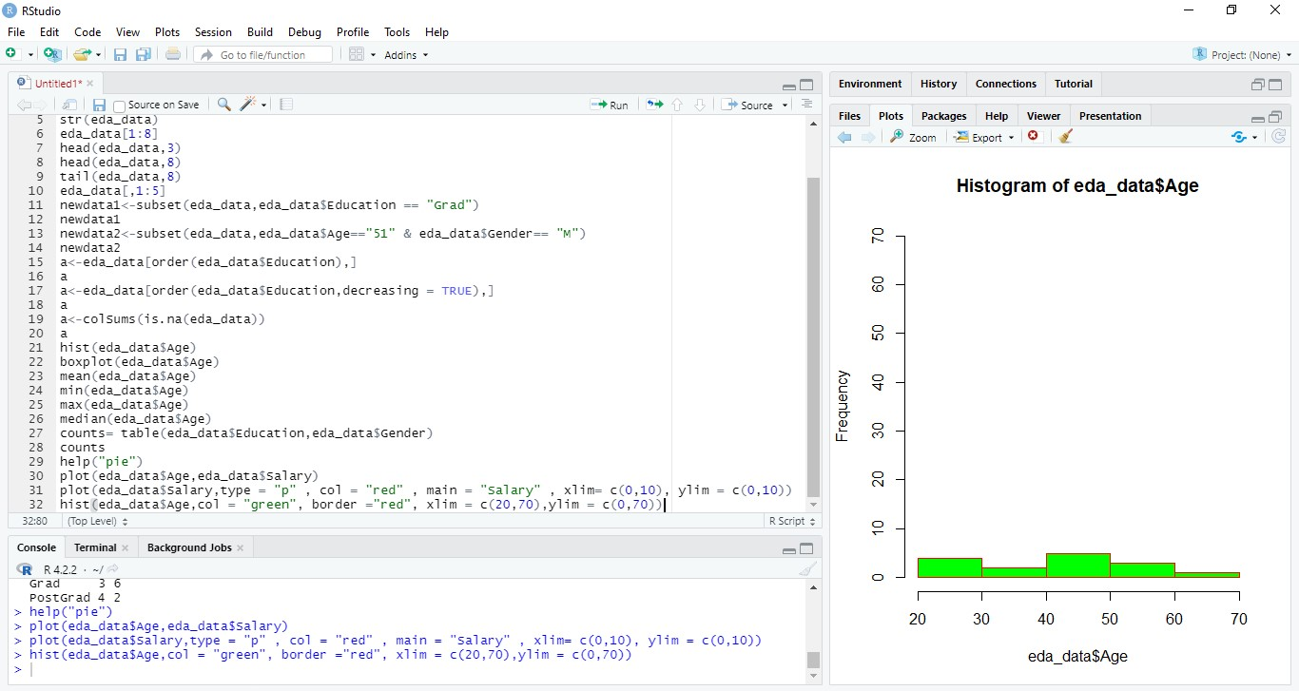

26)barplot(counts, main = "Data distribution by education vs gender", col = c("blue","red"), legend.text=TRUE, xlim=c(0,10))

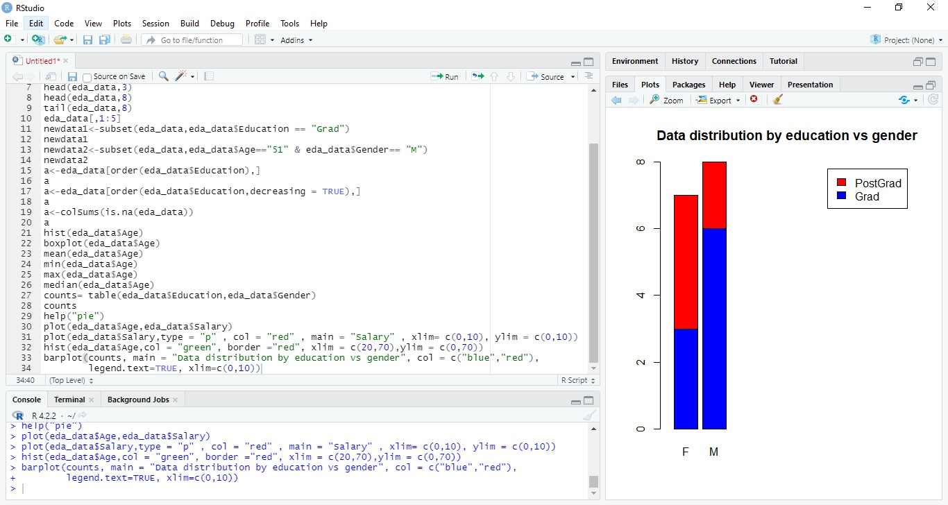

27)pie-chart x=table(eda_data$Education) per<-round(x/sum(x)*100,1)

pie(x, labels = per, main = "City pie chart", col = c("blue","red"))

